Opening the Basket: Sharing Revitalizing and Reconnecting the Stó:lō Sitel Curriculum
Virtual Learning Lesson Notes - East
May 22, 2020, via Zoom, 2:00 – 3:30 pm. Hosted by Mission Public School District 75
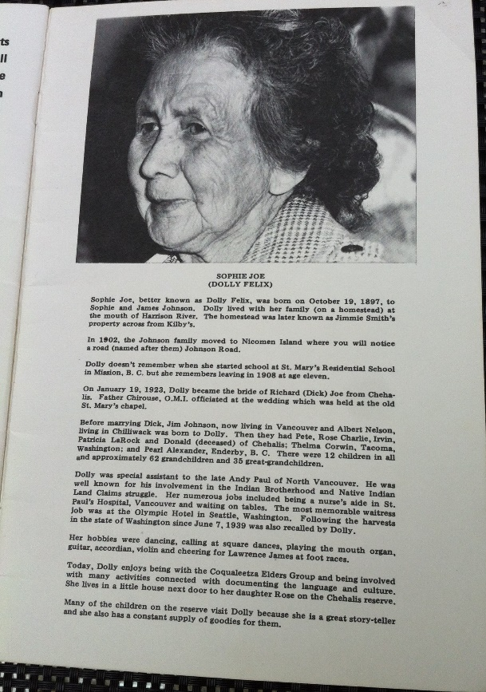
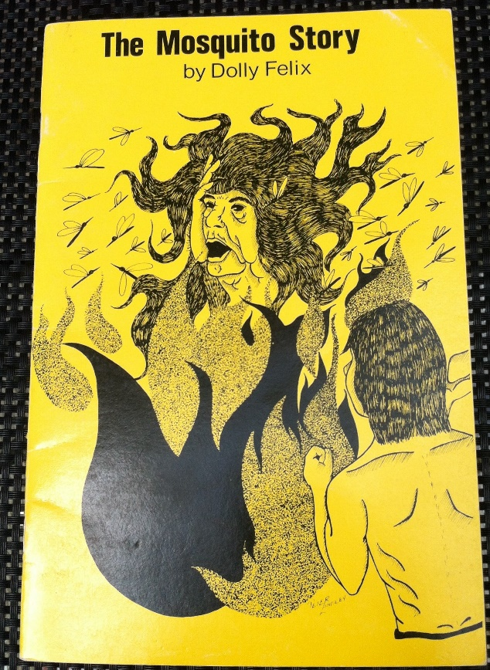
Attendees: Dr. Jo-ann Archibald Q’um Q’um Xiiem (UBC), Lolehawk (Laura Buecker), Siyamiyateliyot (Elizabeth Phillips), Siyameqwot (Vivian Williams), Peggy Janicki (SD75), Patricia Pruim (SD75), Jessika Rowley (SD75), Alison Sward (SD75), Jacquie Blaschek (SD75), Rod Peters (SD78), Brenda Point (SD33), Laura McDonald (SD75), Valerie Tosoff (SD33), Nicole McCall (SD33), Gina Graves (SD33), Kathryn Popma (SD33), Greg Lawley (SD78), Adrian Fuerth (SD78), Bridgid Dunning (SD78), Nikita Tournier (SD33), Julie Malloway (Coqualeetza), Vivian Searwar (SD75)

Opening Remarks: Lolehawk, Siyamiyateliyot and Siyameqwot
Lolehawk:
“Today, I am a visitor on the traditional lands of the Songhees and Esquimalt territory of the Lekwungen speaking peoples. I am here in Victoria, BC. I am Lolehawk, Laura Buker, and my family is Stó:lō and Lake Babine Nation. This time has brought us together to share our stories and our good hearts and minds towards “reconnecting the Stó:lō Sitel curriculum. Here with us is Siyamiyateliot Elizabeth Phillips, and her daughter Vivian Williams to share thoughts on the importance of our river stories.” (We chatted back and forth, Elizabeth and I on stories, and especially the stories that storyteller Dolly Felix shared and how she engaged the children in those stories).
I'm sure at this time in Mission and along the river, the cottonwood fluff is probably starting to fall like snow so much snow, and my grandmother, when I fished with her along the river always told me that this was the time of the first salmon. The spring salmon coming out right up our river and it is the time of honouring of our first salmon ceremony, such a special time”. I've learned that you know, we follow the teachings of our elders. We were taught by our grandparents that, we're in nature, and like my grandmother would say it's time. It is time for this.” It is time for the salmon to come up the river.”
Siyameqwot:
“I grew up with my grandmother. And she always told me stories, I could picture the story in my, in my imagination. I didn't know it was a learning tool until I was an adult, but she brought the story to life. She always added different things each time she told me story, as a new element or new texture for me to add to my memories. She told me many stories and each time. She told the story. She added something new. Something and just keeps my mind going, and today those stories, they are teaching tools for our children. It's teaching children, maybe they won't know what they're learning, but, you know, they're being passed down, as our oral history or oral story from time to time.”
Dr. Jo-ann Archibald Q’um Q’um Xiiem
I am here on the traditional and unceded lands of the xʷməθkʷəy̓əm (Musqueam), Skwxwú7mesh (Squamish), and Tseil-wu-tuth Indigenous peoples.
To Lolehawk, Siyamiyateliyot and Siyameqwot, it's great that we can connect in different ways but you're still teaching us and sharing the importance of Stó:lō stories and, emphasizing the importance of telling our stories and keeping them going in that way in the oral tradition. Now, we are using other forms of having people, especially children learn from the stories. And it's wonderful to see everyone who has agreed to be a part of this project we call Opening the Basket. Sharing, Revitalizing and Reconnecting the Stó:lō Sitel Curriculum. What I'm going to do is give a background to the Stó:lō stories and introduce some of the principles of working with the stories using an approach that I call Indigenous Storywork.
The group that began this Stó:lō Sitel curriculum was called the Coqualeetza Elders. I think Siyamiyateliyot was probably one of the younger, very young elders at the time, who was a fluent Halq’emeylem speaker. This group, some of them started in the late 1960s, where they were engaged in revitalizing the Halq’emeylem language and recounting and revitalizing Stó:lō history. They met together, maybe as a smaller group and they would meet in different homes and in different communities, once a week, and they shared food and talked about the Halq’emeylem language and they also shared stories. We have Julie Malloway from Coqualeetza Cultural Center with us today. And Brenda Point is also a Coqualeetza Board member. The Coqualeetza staff provided support to the Coqualeetza Elders and helped with transportation. In the early 1970s, instead of meeting at Elders’ homes, they began to meet at the Coqualeetza site in Sardis. They continued these meetings every week, usually every Wednesday. Somebody would cook lunch for everybody and then we would have our prayer and we would eat and chat, talk about things and then we would get to work. And you know in our gatherings, you'll hear somebody say when we are gathered, “ My dear friends, the work is about to begin.” So, you know, that's important.
It's a signal to tell us that now we need to pay attention to what's going to happen. The Elders worked with the linguist and others, the Coqualeetza staff, and they would document their language, moving from the oral into the written form. This same approach was used with their stories. Much of that material was tape-recorded and videotaped using the technology of the time, and subsequently used for developing learning materials. A group of educators also worked with the Elders, because they wanted to ensure that children especially Stó:lō children, were able to learn about Stó:lō history and culture and ways of knowing. At that time and still today, the majority of Stó:lō children attend public schools, but they had also included the Stó:lō Band schools. The Elders felt that all children needed to learn the same things about Stó:lō people so that a better understanding was developed amongst all people. So, you know when you think of it, the Elders were doing the work of reconciliation. Today, we're always talking about the need to engage in reconciliation through education. But it was the Elders, who were leading reconciliation since the late 1960s to today. Between the 1970s- 1980s, we used the subject of social studies to develop Stó:lō curriculum because that was the only way, the only little opening, we had in the public school system for including Indigenous content.
And so that's what we used, and we spent a lot of time with the Elders where they thought about particular stories, which might have been related to fishing and hunting, and thinking about the stories related to how Stó:lō communities were traditionally established. The Elders decided which stories would be used for the curriculum and whose story version would be used. Some stories have been told by various Stó:lō storytellers over the years.
Dolly Felix was one of the Elders who was known for her engaging storytelling abilities. With each story booklet we worked with the Elder who shared the story and added a bio and photo about the Elder. We felt that this process was important, that it was and is part of protocol, to indicate who the storyteller was at the time. The group and the educators worked carefully with each Elder to ensure that the representation of the story in text was the way that the Elder wanted it. And at the time, we were dealing mainly with text, so we made sure that we completed this verification process.
The Elders also approved the images that went with the story. A lot of careful work was carried out and we felt that it was our responsibility to ensure that we could take the oral tradition and use it to create a story in text. Their orally told stories became learning materials that reflected what the Elder said and how they wanted it represented. I think today the term, authentic, is used; this is an example of authenticity and what it means and how to do it, that we carry out our roles responsibly. The Elders took time to think about, to talk about, or to engage with particular stories, and each week when they would meet, we would show them what we had done with their story and then they would approve it.
This process also demonstrates respect because we wanted to ensure that the Elders felt comfortable with how their knowledge and how their story was being used, and that we took time to develop the relationships with the Elders so that they could trust what we were doing in our role as educators for the curriculum. We also learned how important this responsible and respectful work was.
Today, we opened with Siyamiyateliyot’s good words, and Lolehawk’s words. There were ceremonies for various phases of the work, which we also learned, were an important part of Indigenous ways of being and knowing and that's an example of reverence that we can show towards our culture. Much of this storywork was getting ourselves ready to work with these stories. As part of this storywork, we took the verified stories, and then we worked with schoolteachers to create pedagogy that they could use in their classrooms.
The aforementioned process that I shared exemplifies Indigenous storywork principles. As I reflect, respect was shown towards the Elders, for which time and patience were needed to develop working relationships with them. Sometimes the Elders weren't sure about a story, or they weren't sure about a particular part of the story. So, they had to take time to think about it, to talk with others until they felt ready to verify parts of the story. And that doesn't happen unless you have a respectful relationship. We must remember that the Elders also experienced colonial laws and policies that prohibited them from practicing their culture such as gatherings, ceremonies, and speaking Halq’emeylem. Formal education through the Indian residential schools separated children from their families for generations.
We were also learning a lot ourselves, and some of us, like myself, had grown up listening to various stories. Sometimes when we listened to them, we didn’t understand the important meanings or lessons that we might get out of a story, until we were older. But then, we realized that we were lucky to have these stories. As an adult, we had another opportunity to learn from the stories. I believe that we developed a reverential attitude towards the Elders and the stories. That's a very individual and subjective approach. Reverence is like a very deep respect for the stories, especially for the power and the beauty of the stories. The notion of reciprocity is a way of giving back. Elders have often said that if they were given the gift of various knowledges, then they also had a responsibility to teach others, especially the younger generations, which is intergenerational learning. This way of learning is also a form of reciprocity. We often hear Indigenous people say it's important to give back, if we've received something whether it's knowledge, or a particular skill. We have that value and practice of reciprocity to give back, and that's a way of keeping that knowledge going.
These four R's [respect, reverence, reciprocity and responsibility], I believe are a way to get ourselves story-ready. So, for the educators here in this project it's an opportunity for you to get yourself ready to work with the story. Remember I said: When we're at an important gathering, somebody says, ‘My dear ones the work is about to begin’. So, with this project I say , “My dear ones, the work is about to begin.” We have gathered together, educators, who are interested in knowing more and educators who may be new to this area, and who may wonder about making a mistake, or offending someone, which is an important feeling to acknowledge, but we also have educators here, who have been doing this work for awhile, and who can help as needed. We all make mistakes. I've made lots of mistakes in relation to stories. An Elder from Kwantlen, Cheryl Gabriel, said to the group of teachers from the other zone on this project, “Well, yes I made a mistake, but next time I'm going to do better”. When I heard her soothing words, I thought, yes, next time ,I'm going to try to do better. I think that's important because we can make mistakes, but given another opportunity, we can try to do better to correct any mistake we may have made. This idea makes me think about reconciliation.
That's part of reconciliation, we acknowledge the difficult history that Indigenous people have had to endure. And at the same time, we can apologize for some for those policies but then, we can do better. And it's up to us to do better, and how we can do that now, is that a group of us have come together to “open the basket” once more. That's what the Stó:lō Sitel is, it’s a treasure basket. When we first developed these teaching tools, we put all the materials into a basket. That was a treasure basket. That was many years ago. But since then, of course, other materials and other needs and demands have come up and now we're at a time, with the redesigned K-12 BC curriculum that we can go back and open the basket. We have another opportunity to work with these wonderful stories in this redesigned curriculum in the schools. That's what we're doing with this project. The other Indigenous storywork principles of a holistic approach, interrelatedness and synergy can be used when we actually work with the stories.
Together we can learn about and practice ethics that relate to Stó:lō stories, such as introducing the Elder, and acknowledging the Elder who told the story. This session was meant to introduce the “Opening the Basket” project so that we can start to develop a working relationship amongst each other - members of the working group and participating teachers of this project. Most importantly, we want to create a process where we care for and share with each other through this Indigenous storywork process.
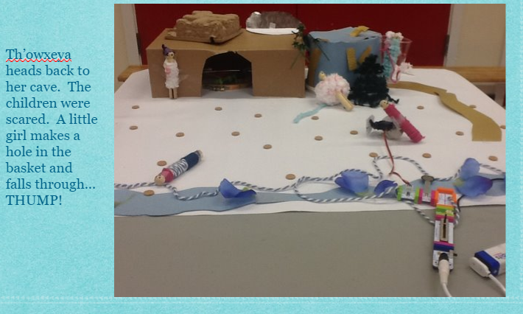
Peggy Janicki:
“My mother is Mary O'Connal, who was part of the Stó:lō Elders beginning in the 1960’s and part of Coqualeetza for many years as a weaver, I wanted to share what I did in Abbotsford School District in 2016.”
Notes from Peggy’s presentation:
- With Th'ōwxeya, the Mosquito Story, I used the version in the book, I am Stó:lō (1998).
- Worked with a teacher Mr. Dirom, the Technology teacher, and Grade 6 students using Little Bits to recreate the story
- Little Bits are little electronic pieces of Lego with battery packs which enable mini lights, fans, noise makers, etc; rudimentary coding
- The student’s objective was at their table and in small groups, was to recreate their part of the story.
- The culminating activity was for the whole group to travel from table to table to see the final story, through the creativity of the students with Little Bits and paper recycling (cardboard, tape, straws, plastic cups, clothes pegs, paint paper etc)
- Combines STEM and Indigenous Ways of Knowing and Indigenous storytelling
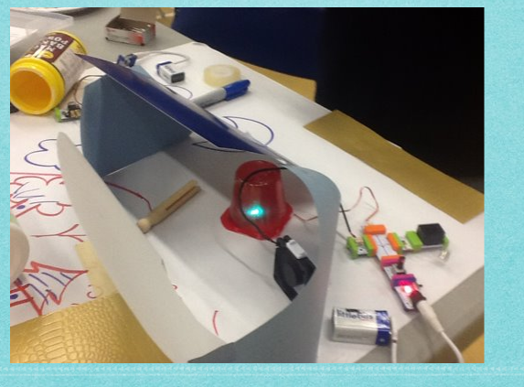
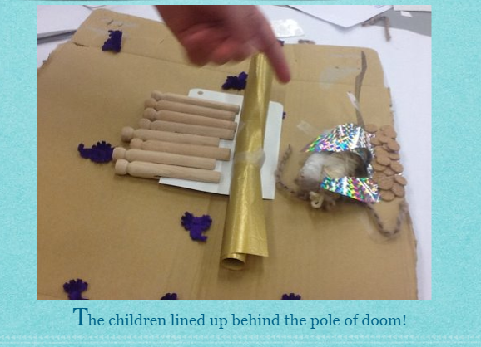

Group Share: [I wonder/imagine]:
- When we go to the library, we often we see the book sitting on the shelves without knowing the background of the story, Jo-ann’s explanation and history of these stories is information that we need to start to our own relationship with the text to support us in bringing these stories to life in the classroom
- Appealing to the senses while listening to the story: What do you hear? What do you see? What do you smell? etc
- Using modelling clay with students as they are listening to the story
- Themes of The Mosquito Story as Life Lesson: Stranger Danger, time management
- As students grow older, they may come to realize and understand the story (ie values or morals)
- Sometimes the teaching from a story may not be evident immediately, but come back to you years later
- Retelling and rehearing a story gives makes space to revisit the meaning of the story later in life, and your understanding will deepen – we grow, and our brains have grown, our bodies have grown and our understanding of the world has grown and so we are different which enables us to receive the story in a different way and notice differences in how you understood now as compared to previously; whatever time and place you're in you're going to pick up what's important to you, what's happening in your life.
- Stories are meant to be read repeatedly.
- Suggestion that the teacher would choose one book and stream that same story through the year, use it for different social emotional learning opportunities; What is your relationship with this story right now? How has it changed over the course of the year?
- Being a storyteller takes practice
- There is a difference when listening to a story and reading the story, as each storyteller has their own way of telling the story and their own version of the story, like a living version of the story (not a matter of accuracy or correctness); how to listen with your ears and your heart; sometimes there are parts that can get lost in the written translation of the story; it is a different experience when we hear the story
- Picture storybooks are not only for primary students, they're for older students as well, including high school students; is about receiving that story and what you know what has been your life experiences, up to that point in time when you hear that story and then when you hear it again and again, even as an adult
- Listening to the story while walking adds another dimension of understanding to the story – to be alone with one’s thoughts and the story, without the distractions, a way to be one with story, focused and concentrated and moving with story
- sharing multiple perspectives and how it extends our thinking; i.e. storytelling and art
- How do stories connect to memory? How do they connect to history?
- Storytelling is not just about writing; sometimes we get stuck in the mechanics of writing, and lose the focus of oral storytelling, oral storytelling allows students to shine in a different way; is about equity and meeting students where they are
- Leaning into discomfort is required by all educators as part of a pedagogy of discomfort
Julie- Malloway (Coqualeetza):
- Coqualeetza is currently working toward hiring a part time person, to do interviews with the Elders and other members in the communities, a gathering of stories during those interviews.
- Also looking into the possibility of further curriculum development, and just work on curriculum, and creation of lesson plans
- Need to get suggestions from teachers on what we could develop that would be useful for them.
- Looking at having stories made into audio, and that they can purchase the audio online, digitizing some of the stories
Next Steps:
- Participating teachers will complete the survey by June 5 2020.
- We will reconvene in September, using the results of the survey to inform next explorations with Stó:lō Sitel curriculum
Resources:
- Please see the project web site for resources, https://stolositel.weebly.com/resources.html

